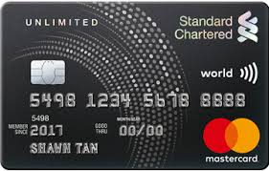 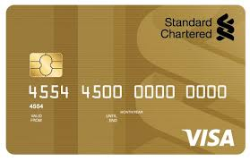

**LOG ON-Steps & Instructions**

CCMS Steps & Instructions

System: IBM Personal Communications Workstation Program Version 6.0 for Windows

**Step 1: The below mentioned configuration steps to be performed in order log on to CCMS.**

**Click on the Communication Tab>>Select Configure**

**Click on Link Parameters under Customize Communication Tab**

**Please the provided host ID & and corresponding port numbers and click “OK”**

**On the enter application request screen: Enter the corresponding LOGON ID provided by the CCMS team and press Enter[right Ctrl].**

**Enter the user ID and password and then press enter under credentials request page in order to login in to CCMS.**

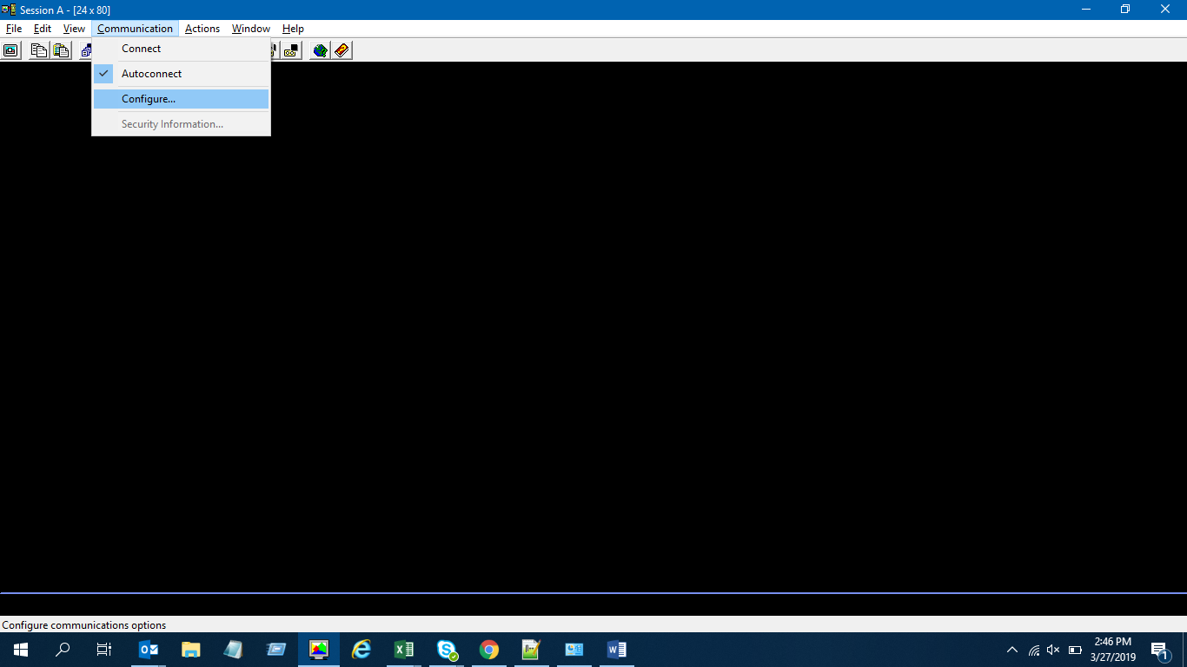

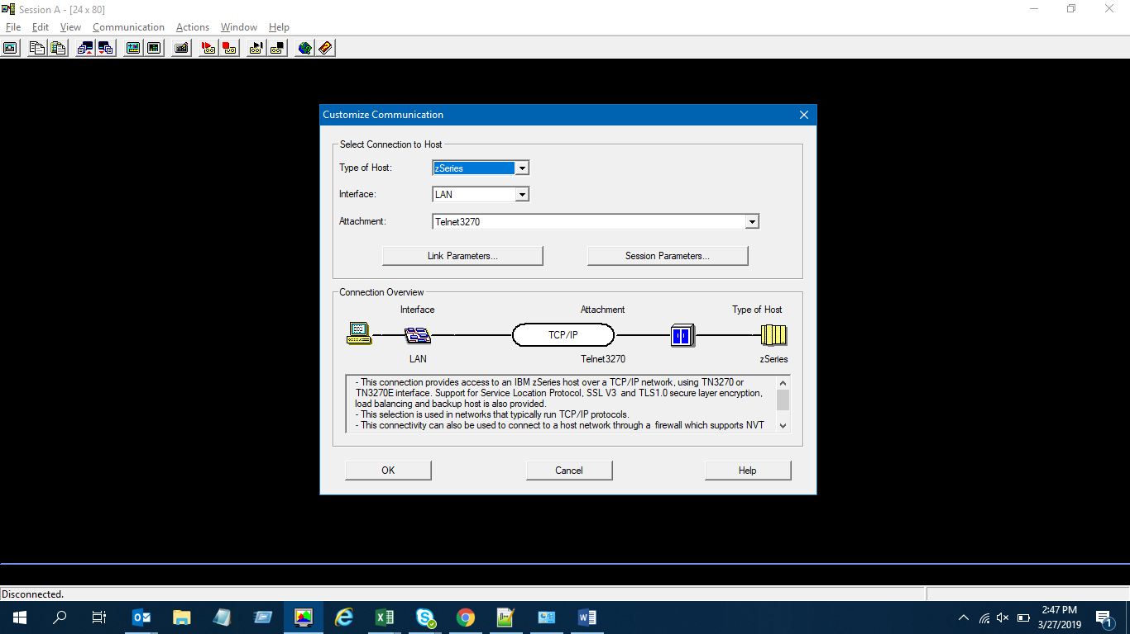

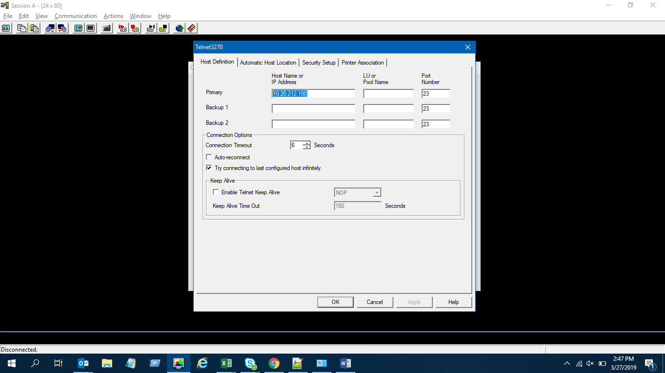

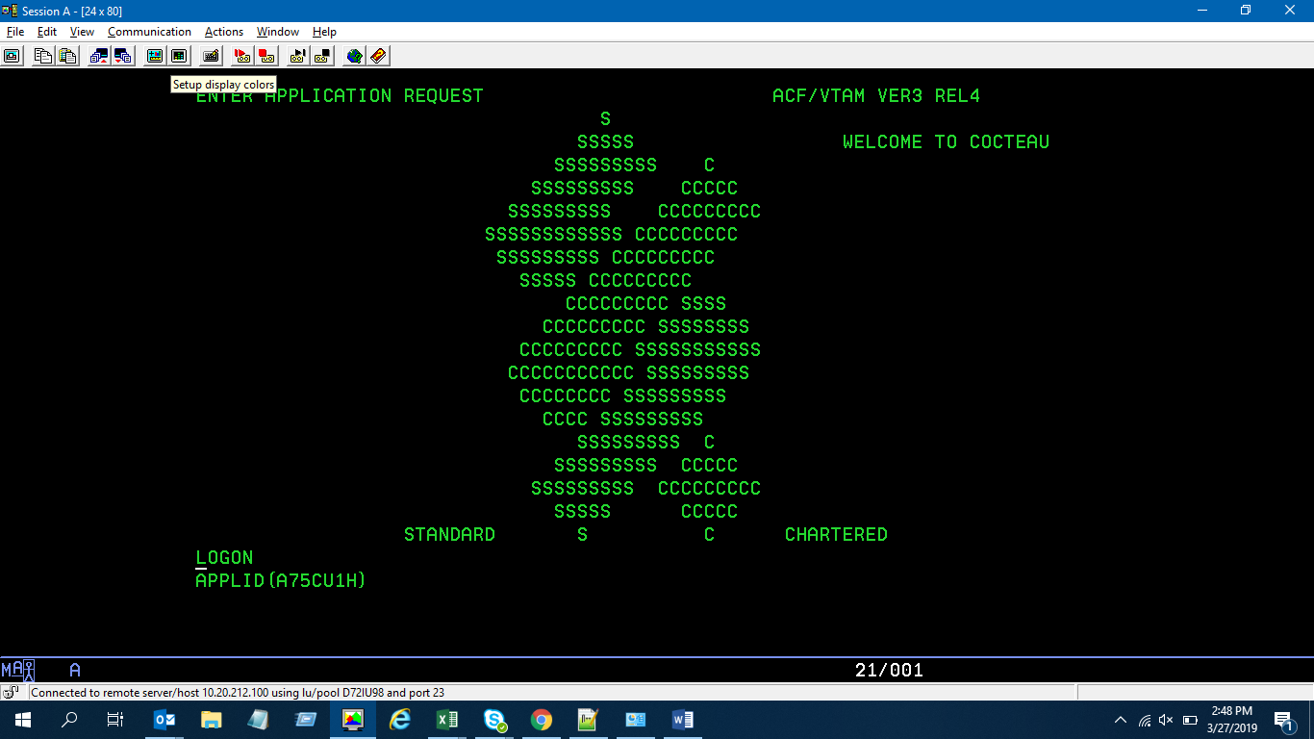

**Please enter the log on key for e.g. LOGON APPLID(A75CU1H)**

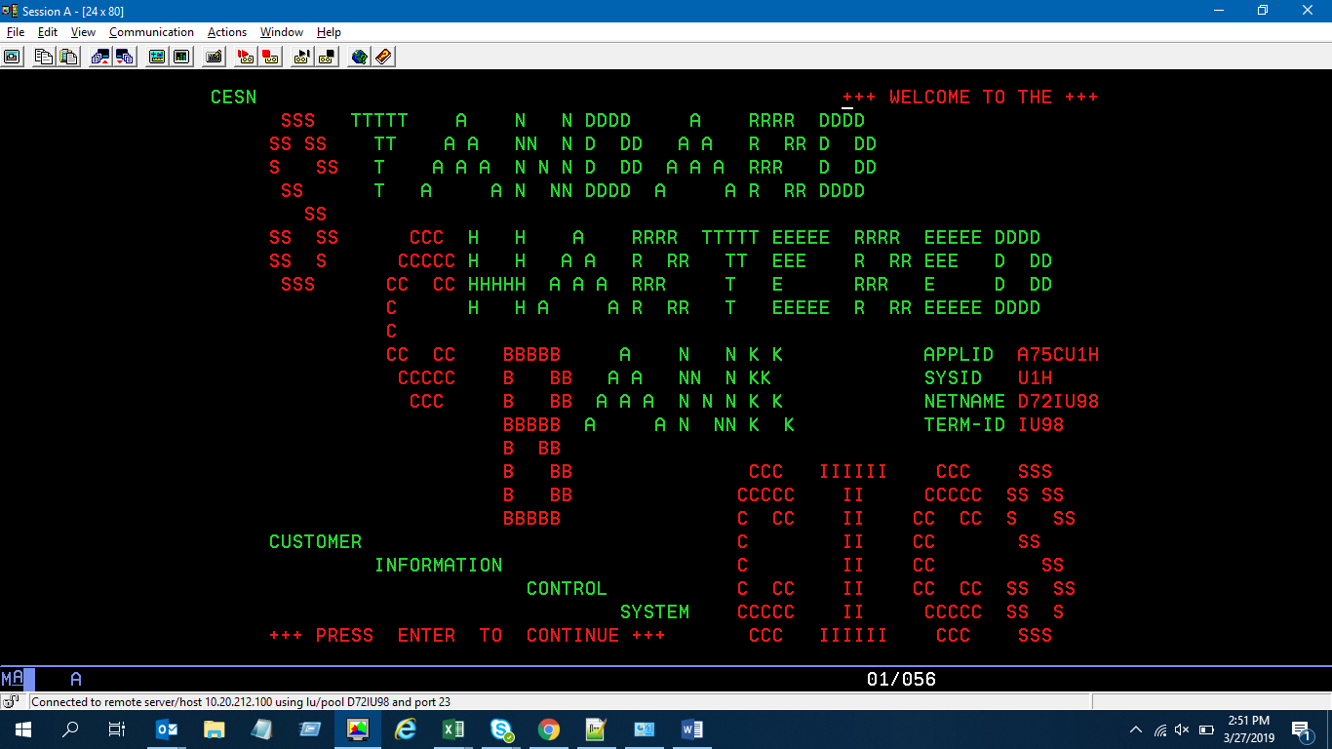

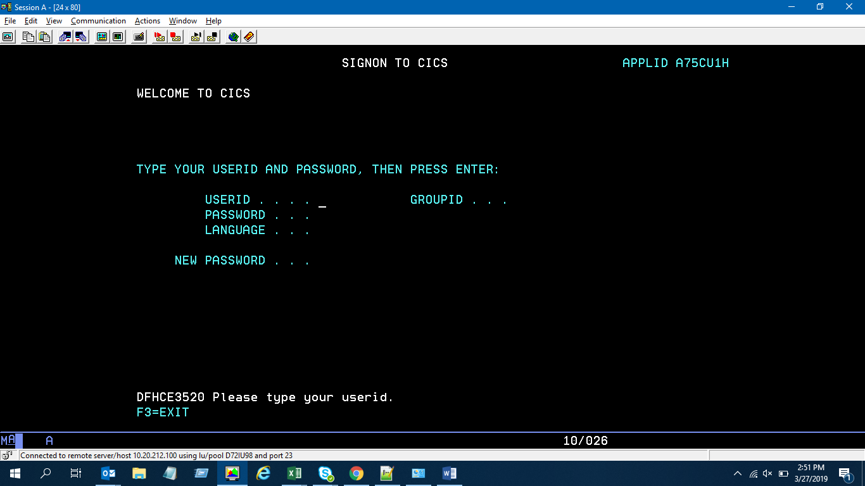

**PXID – Customer Account List Inquiry**

PXID screen is used to inquire the profile of the customer using the 01-NRIC, 04-Passport, RL-Relationship ID, IM-ICM ID, RX-RL without ID Type [The ID type using which customer is to enquire is to be keyed in ID Type section and ID Number to be keyed in the latter section.

For e.g. ID Type: RL and ID Number: **0100000000079598**

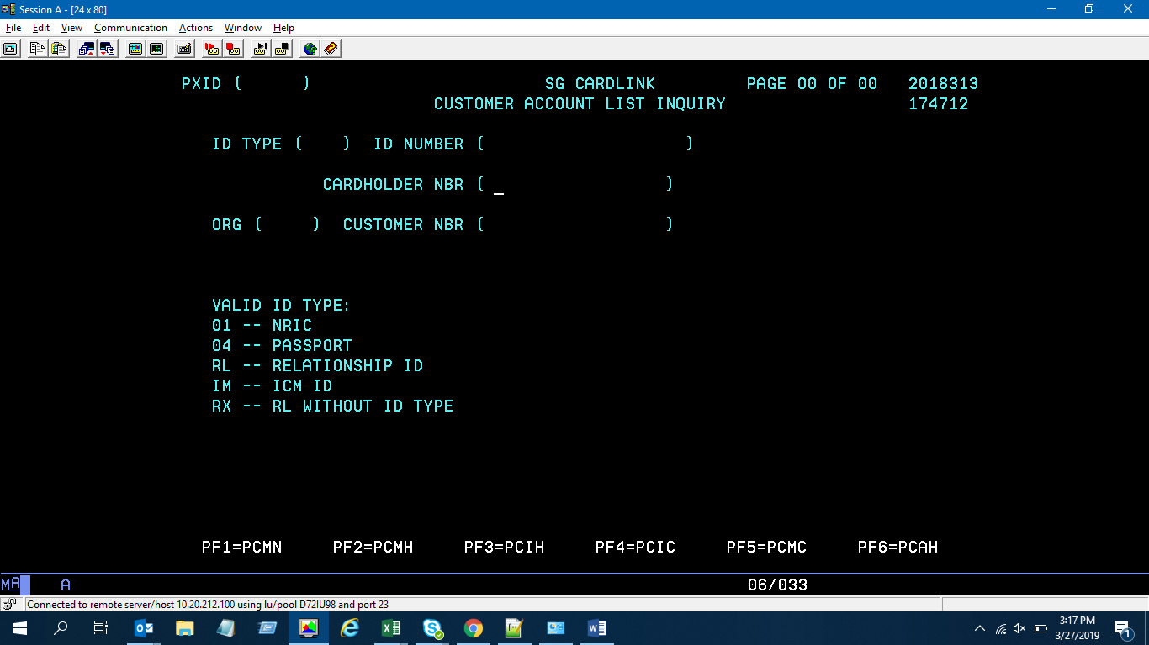

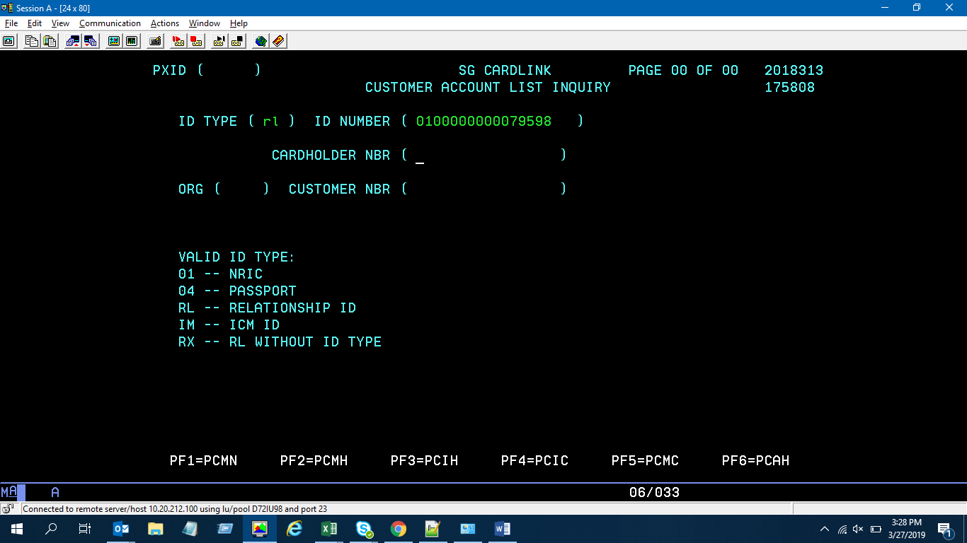

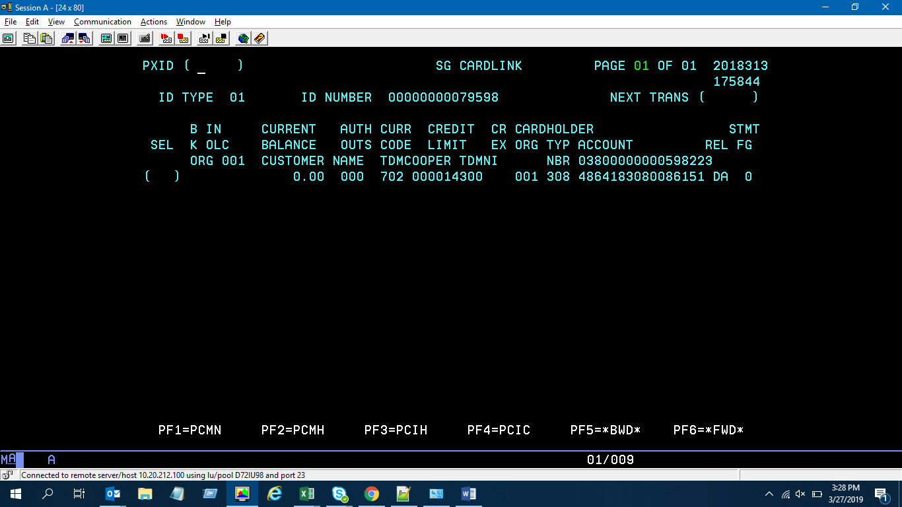

**PCIC – Customer level validation (Credit Line = PCIK Credit limit)**

- Name - Address - Billing Cycle - Employment details  
- Credit limit - Cash Limit - Avail Limit

- P8 ID (consol statement) - Consolidated statement flag can be made available only ETC client types[i.e customer having an active credit card profile applying for another credit card].

In P8 ID=rel ID of the customer.

For a NTB customer, consolidated statement (P8 ID) for the customer is always “N” in ICM and blank in CCMS.

Consolidated statement flag can be viewed in ICM under the cross-reference tab against credit card product.

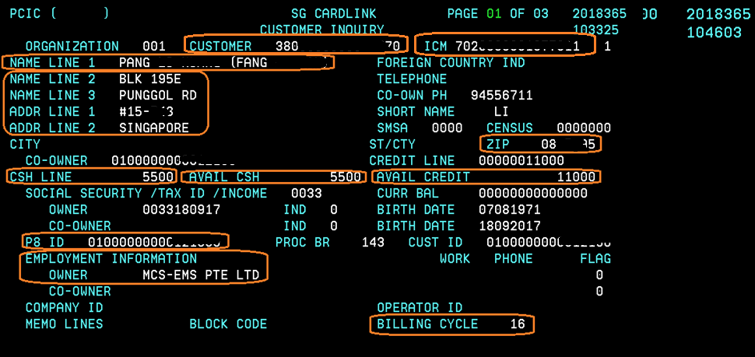

**PCSS – Customer level validation**

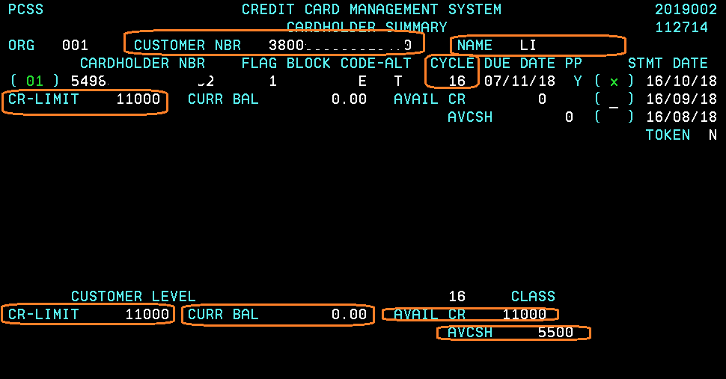

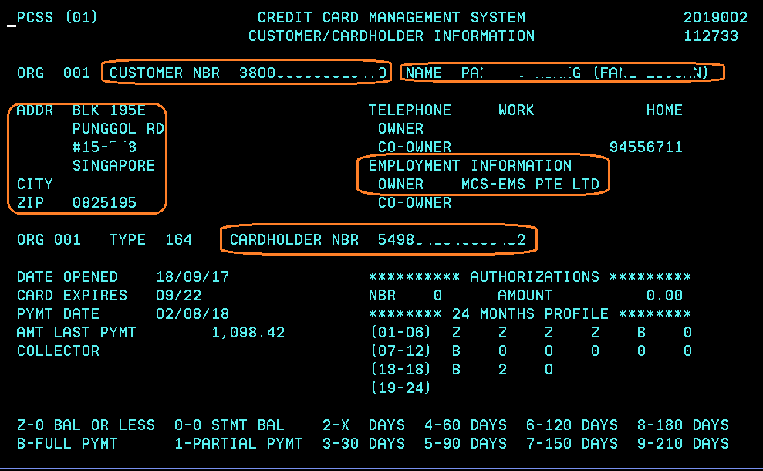

**PSIA – Card activation & Oversea activation**

(should have another code for Digital Card activation)

PSIA screen 01- is applicable for physical card activation and overseas activation.

Physical card activation is applicable only for Credit Card Products and not for Cash one[loan on card].

Physical card will be activated only once the customer receives the card in hand[i.e via postal and activates the card by himself]

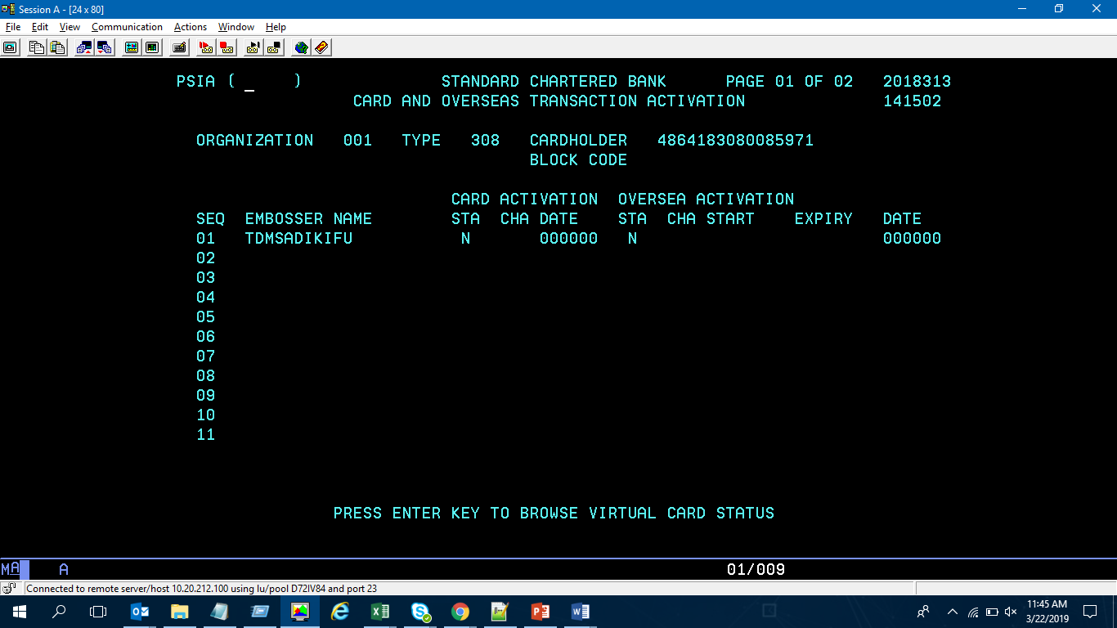

PSIA 02 screen- is applicable only when card is activated digitally via the customer front channel.

Case 1: Digital card activation is not applicable for cash one products (i.e. accounts starting with “97022”- Cash one 280, 281 & 287)

Case 2: In exception for Cash one 280 digital card can be activated for additional card provided to the customer [i.e. Visa Cash one Platinum “430092”]

Case 3: Customer can proceed with either digital card activation or without digital card activation for credit cards in scope.

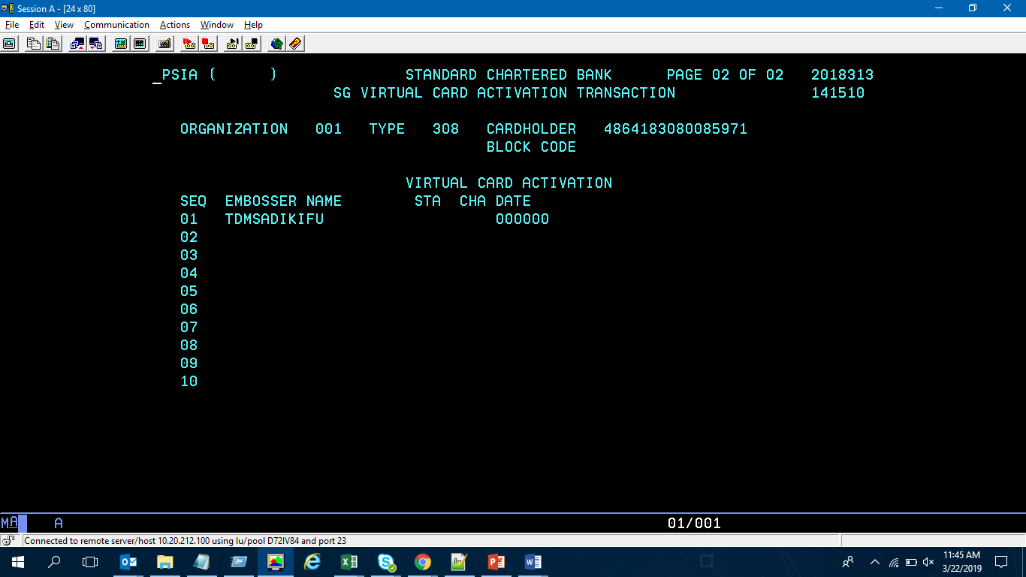

Screen below depicts the physical card as activated for the customer.

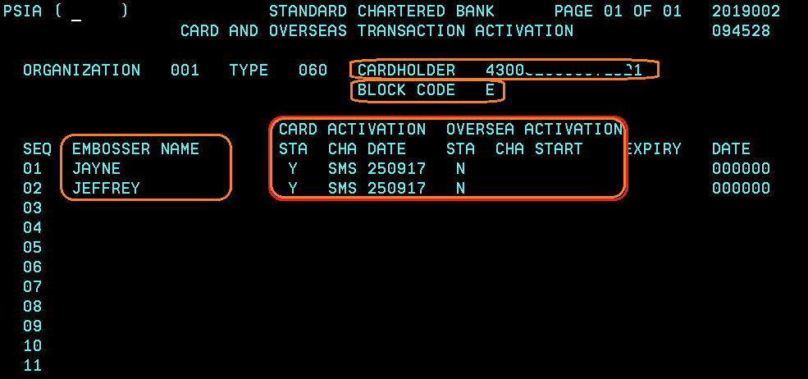

**TMMN >> TMLO >> TMIQ** (the below mentioned screens are used to inquire regarding the App ref, Promo Codes and Sub channels codes- which is validated based on the channel from which the customer has applied).

In simple words, MEMO INQUIRY is the heart as it sets the rules for customer offers, fees & benefits.

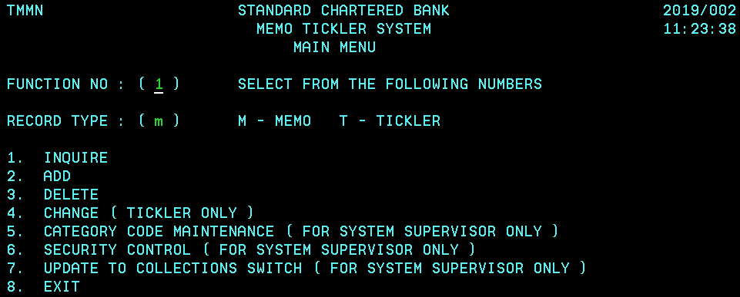

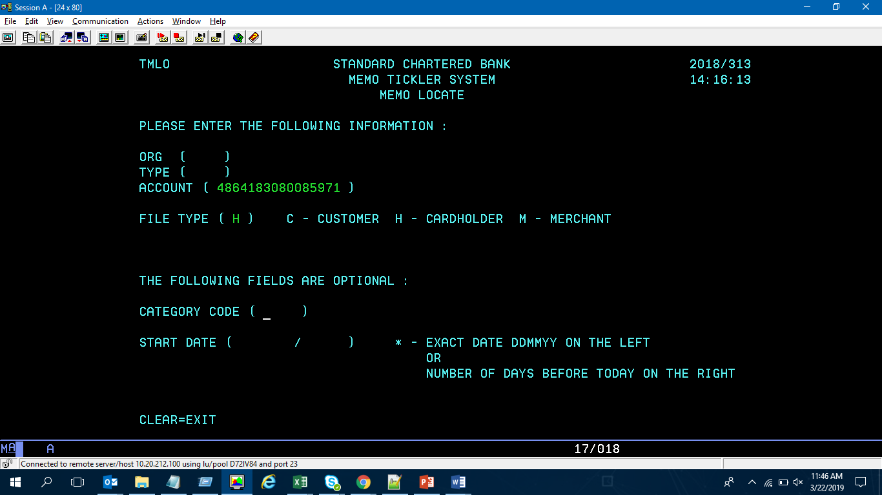

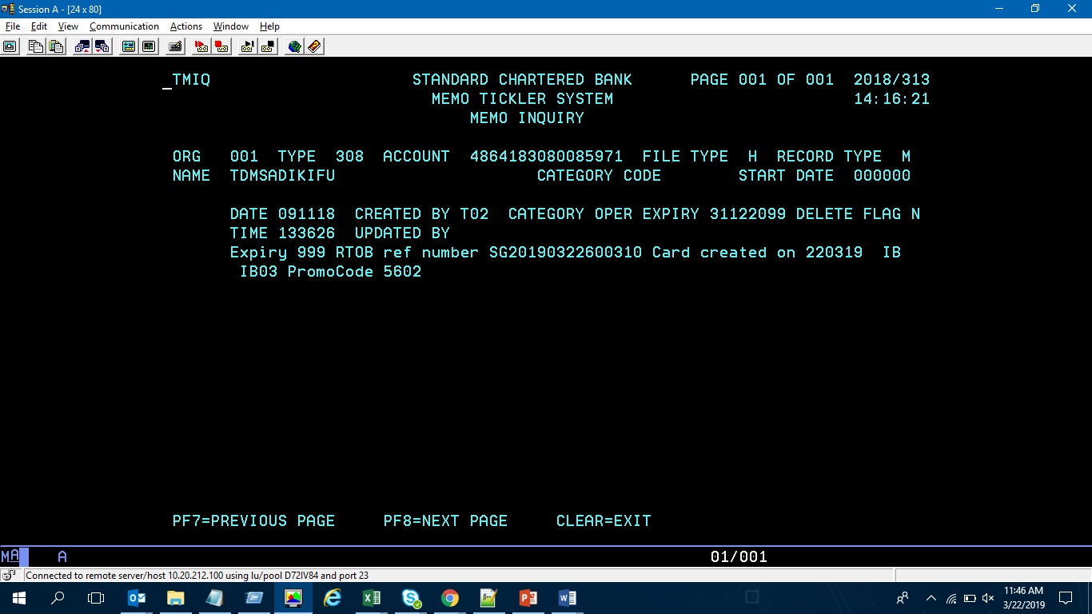

**PPIS – CashOne billed & unbilled amount**

Remaining balance total = remaining instalments unbilled amounts

Unbilled Principal = $13,588.30

If client does an early redemption, the **“EARLY REPAY HANDLING CHARGE”** would be 3% of Unbilled Principal = $13,588.30, hence it is $407.64

**“INTEREST SAVED”** is based on remaining interests that is not billed, as in the event of an early redemption, this would not be charged.

**“NEXT BILL AMT” = “EARLY REPAY HANDLING CHARGE” +** Unbilled Principal ($407.64 + $13,588.30)

**“EARLY REDEMPTION DUE” = “NEXT BILL AMT” = “EARLY REPAY HANDLING CHARGE” + CURRENT OUTSTANDING**

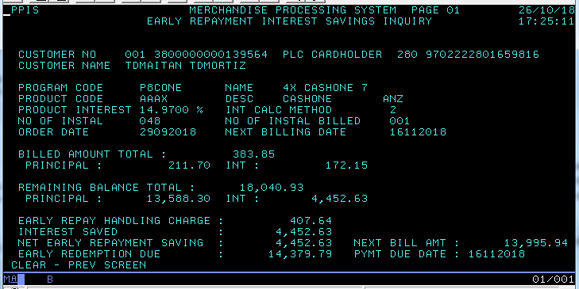

**Steps to identify Staff in CCMS: In CCMS, staff profiles have certain privileges unlike the usual clients- POTs and SUBPOTs, Promo Codes, Fees Waivers get updated as per the grid provided by product team in CCMS [product grid differs from country to country]. Staffs are usually offered less interest, annual fee waivers etc;**

**User Code 1= ST in PCIH screen [depicts that customer is a Staff]**

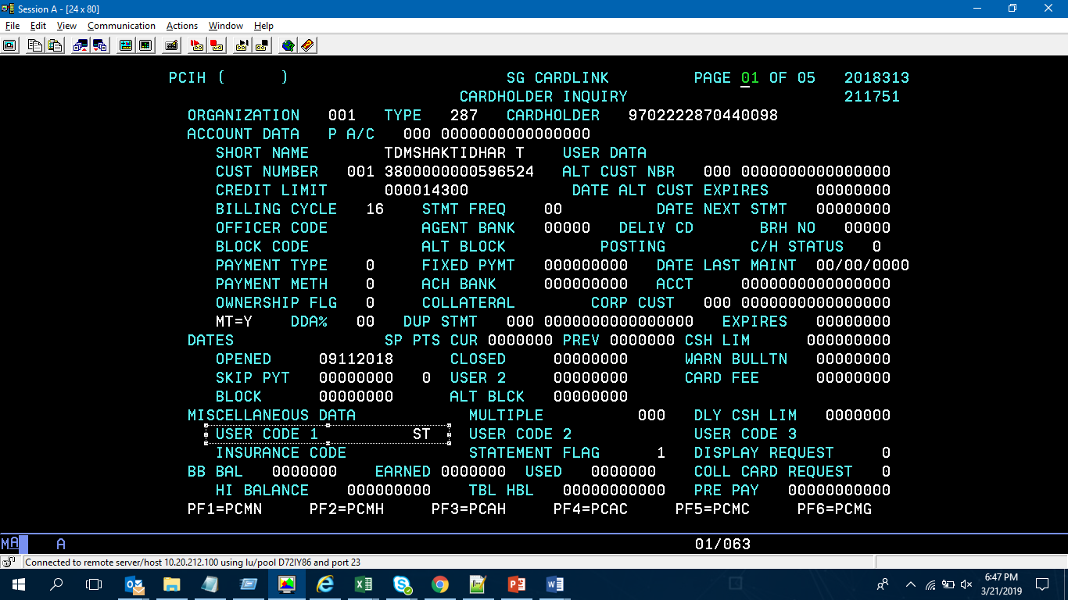

**Staff Flag under PSCI screen should be updated as STF for the customer. For all non-staff applications, it will be updated as STN for the customer.**

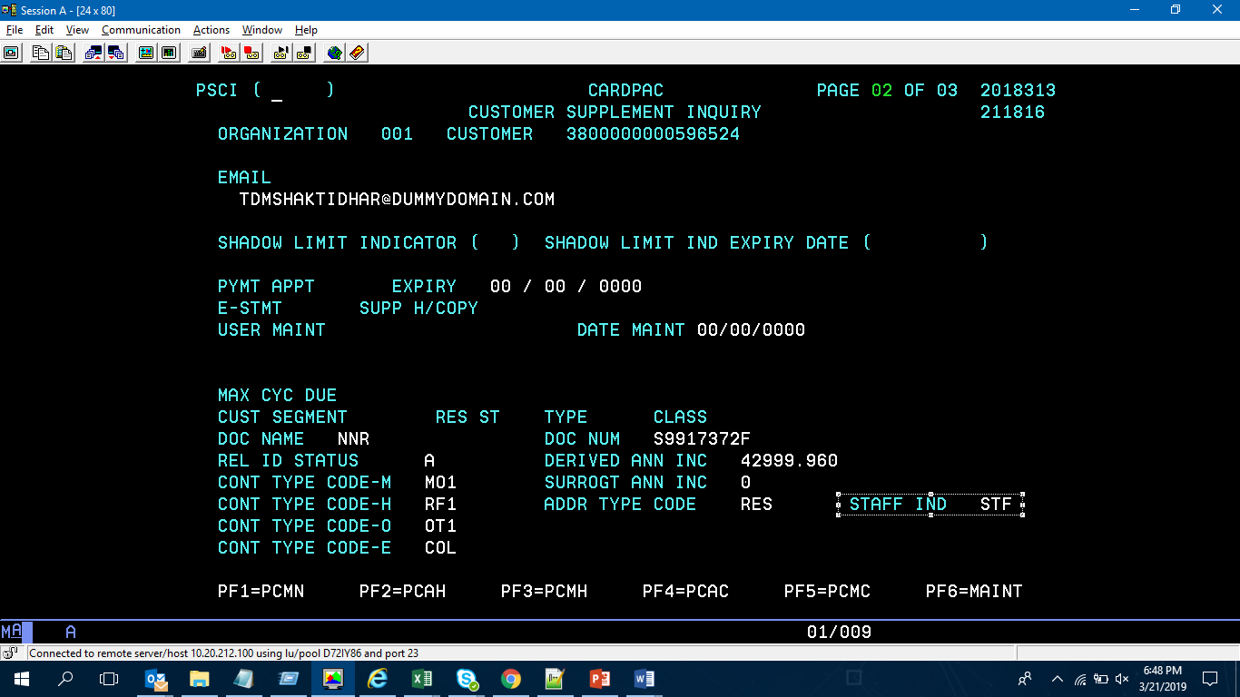

**Owner/Employer Name to be named as STANDARD CHARTERED BANK or subsidiaries of the bank e.g. STANDARD CHARTERED BANK PLC**

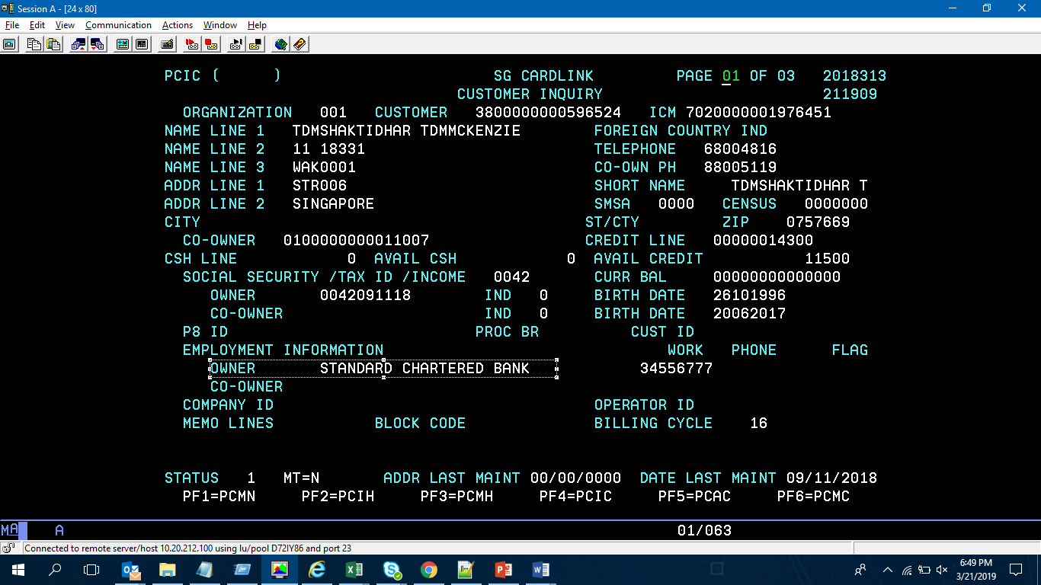

**PCIH [02 Screen] Identification of Supplementary Customer**

**(Or)**

**PSIH [01 Screen] Identification of Supplementary Customer**

**- Card Embossing Name (E1 = Primary; E2, E3, E4 = Supplementary)**

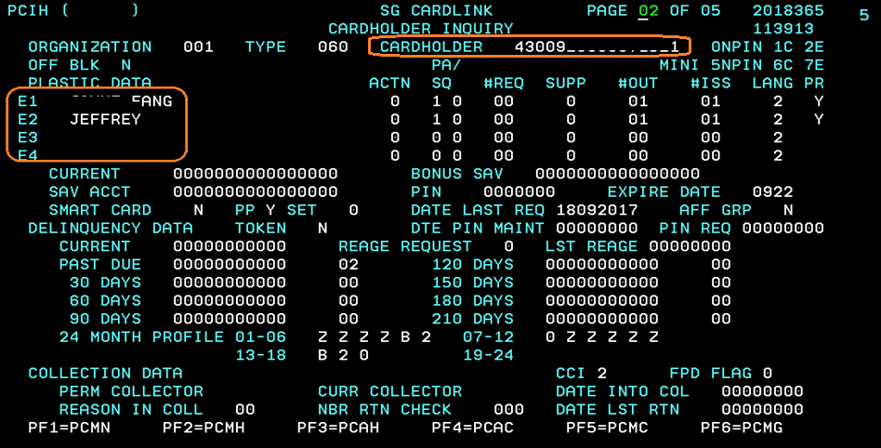

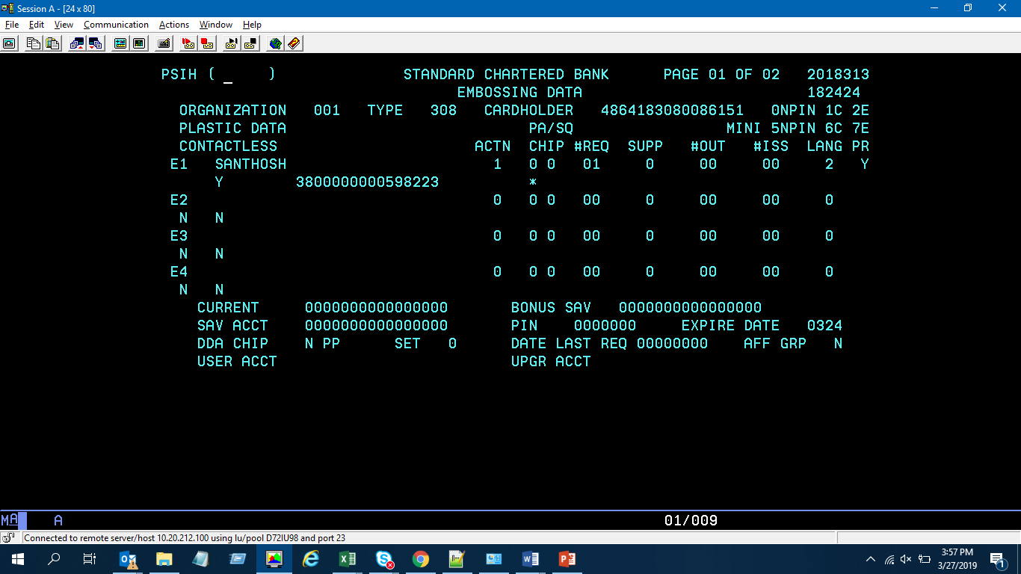

**PSHI-[03rd Screen & 04th Screen]-Product Offering Table**

**Also known as the product offering table defines the privileges for the customer profile. It is validated using the product offering catalogue provided by the country. All privileges for customer get recorded in CCMS based on the table. It differs from country to country.**

**It is used to validate:**

**-Validate Sub Pot 01 “annual fee” and 12 “promo code”**

**-(check on effective and expiry if it is indeed the setup of 12 mths / 24 mths etc)**

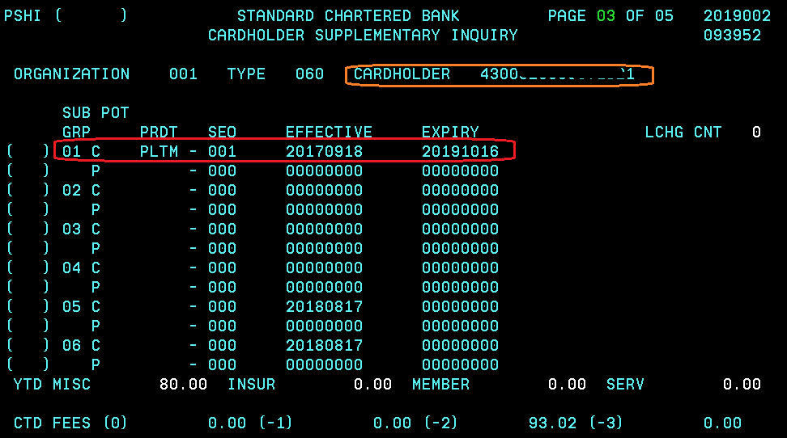

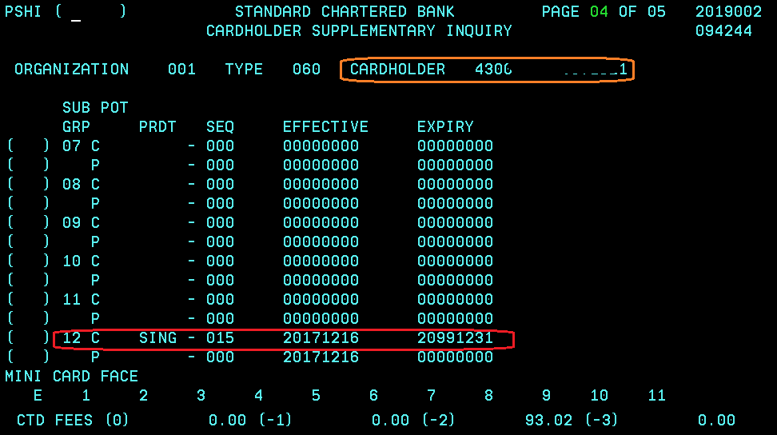

**PPIS – CashOne billed & unbilled amount(2)**

**Identifying Product Interest Rates & Instalments for Cash one: The product interest rate is based on the Promo Code & Tenor. The promo codes differ for each product and is the document for each country is provided by the business. Effective Interest Rate is an important criterion that has a direct customer impact. Therefore, validating the values surrounding as per the BRD is critical.**

**The value surrounding EIR are as follows:**

1. **Product Offering Table Occurrence (PCIH 03rd Screen)**
2. **Memo Inquiry>>Promo Codes [TMMN >> TMLO >> TMIQ]**
3. **Tenor & Loan Amount**

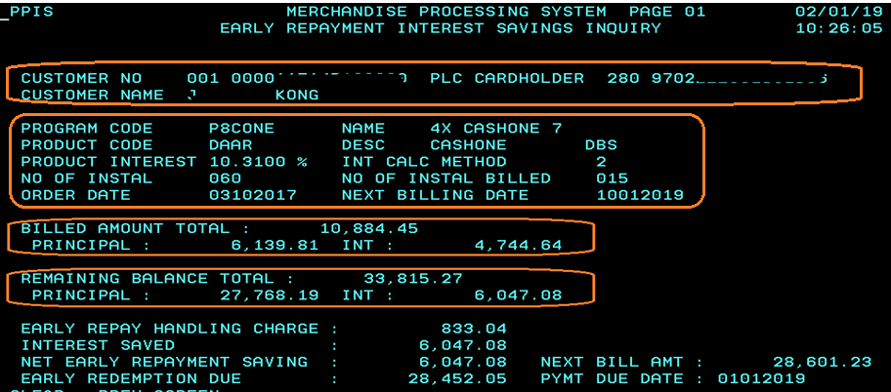

**Block Codes and their description in CCMS:** Block codes define the status of the CCA [credit card account].

|  |
| --- |
| **Block Code        Description** |
| **A          Dead Reversed (>180 days)** |
| **B          Inactive Account** |
| **C          Cycle Past Due (30 - 120 days)** |
| **D          Decline All Charges** |
| **E          C/H Req. Closed** |
| **F           Counterfeit Card** |
| **G          Cancel (Expiring)** |
| **H          Over limit** |
| **I           Not Used** |
| **J           Cancel/Pick Up** |
| **K          Bankrupt** |
| **L           Lost/Stolen Card** |
| **M         Frozen** |
| **N          Non-receipt Card** |
| **O          Deceased** |
| **P          Overdue (X days)** |
| **Q          Credit Problem Account** |
| **R          Refer All Transactions** |
| **S          Lost/Stolen Fraud** |
| **T          Not Used** |
| **U          Un acknowledge** |
| **V          VIP** |
| **W         WIP (Very VIP)** |
| **X          Collected/Closed** |
| **Y          CC Terminated Account** |
| **Z          Charged-Off Account** |
| **Space   Normal Account** |